JS use something called prototypal inheritance

Inheritance is an object getting access to the properties and method of an object

const array = []

array.__proto__ (Type this in developer tool)

This allow u to go up above of the array, which should be Array[]

array.__proto__.__proto__

Go one more upper, which supposed to be object

Same goes to function

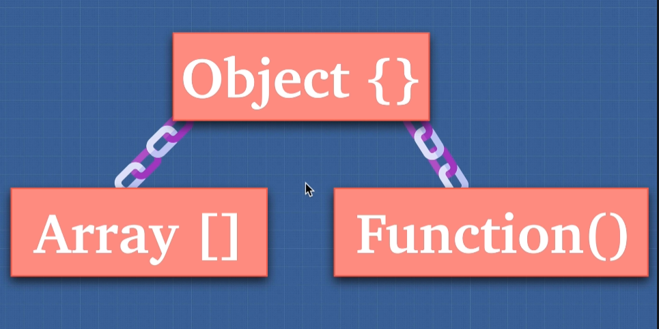

Advantage of using prototype inheritance, is we just need to make once in case you need a lot of similar item. Efficient with our code, saving ourselves memory

